NATIONAL DIVISIONS DIABETES PROGRAM

DIVISIONS DIABETES & CARDIOVASCULAR QUALITY IMPROVEMENT PROJECT

DIVISION DIABETES AND CVD PROGRAMS

A qualitative and quantitative analysis

DRAFT REPORT

Centre for General Practice Integration Studies
School of Public Health & Community Medicine
University of New South Wales
UNSW 2052

TABLE OF CONTENTS

1. AIMS: 1
2. INTRODUCTION: 1
3. METHODS: 2
3.1 Ethics approval 2
3.2 Producing a survey/profile instrument 2
3.3 The Division Profile/survey pilot process 3
3.4 Identifying Divisions with a diabetes and/or CVD program 3
3.5 Invitation to participate 3
3.6 Statements of Agreement were obtained from the following: 4
3.7 Participation rates 4
3.8 Project monitoring 6
3.9 Definitions 6
3.10 Comparisons between Divisions 7
3.11 Data entry and validation of qualitative Profile data 8
3.12 Data entry and validation of quantitative survey data 8
3.13 Data validation procedures 8
4. DIVISION DEMOGRAPHICS 14
5. Appendix 18
5. References 19

AIMS:

The Divisions Diabetes & Cardiovascular Quality Improvement Project (DDCQIP) is part of the National Divisions Diabetes Program. It aims to describe both quantitatively and qualitatively, the contribution of primary care to the management of diabetes and cardiovascular disease (CVD). The project will report on the quality of care and health outcomes of people with diabetes and CVD that are managed primarily in general practice. In doing so the project seeks to bring about improvement in the care of people with diabetes and CVD through feedback to Divisions and practitioners.

INTRODUCTION:

One of the central aims of Divisions of General Practice is to forge better links between General Practitioners and other health agencies, both community and institutional (1). They also play an important role as an interface between general practice and the community providing a population perspective for informing health strategy (2) (3) (4), encouraging a broader public health role for GPs. An important mechanism for achieving this role has been the establishment of Divisional programs across a wide range of areas including collaborative health care planning at regional and State level (5). The shift towards three-year programs of work has provided Divisions with the opportunity to adopt more strategic and longer term approaches to their activities.

General practitioners have an important role to play in the early detection and prevention of diabetes and CVD. Over the last decade or so, there has been a noticeable shift in the management of many chronic diseases (including diabetes and CVD) away from hospitals to general practice. This development has been driven in part by better drug therapies and knowledge with increasing evidence of the effectiveness of structured care for chronic disease in general practice (6). Alongside this there has been a marked increase in the number of people requiring treatment for chronic disease (7) (8) including CVD. The most common CVD complications associated with diabetes are coronary heart disease, stroke and peripheral vascular disease.

In 1996 Australian Health Ministers agreed that diabetes would become one of the five National Health Priority Areas. This decision recognised the large burden of illness caused by diabetes and highlighted the need to focus public attention and health policy on its prevention and treatment. The National Diabetes Strategy 2000-2004 aims to contribute to the improvement of the general level of health by reducing the personal and public burden of diabetes in Australia. The National Integrated Diabetes Program is a Commonwealth government initiative aimed at improving the management of people with diabetes who are managed mainly by their GP. The program aimed to promote the development of nationally consistent education resources and tools for diabetes the program and to foster best practice through general practice incentive payments:

- Practice Incentive Payment to encourage practices to use a register and recall system
- Service Incentive Payment aimed at establishing clinical management guidelines
- Service Outcomes Payment to improve the reach of diabetes programs into the community and hence to increase detection rates.

There has been an increase in the level of resources invested to support general practice management for people with diabetes since the advent of Divisions of General Practice. The Annual Survey of Divisions of General Practice (2000-2001) (5) revealed that the majority of Divisions are active in various programs involving a number of clinical areas. In 2000-2001 the number of Divisions who reported diabetes and CVD focused programs was 104 and 83 respectively. The programs incorporate a variety of activities and forms including GP education activities, guidelines, register recall, consumer involvement and local integration activities(9).

Research continues to show that despite the wide range of population health activities undertaken by Divisions there remains unclarity about how the implementation of population health approaches can be realised (10). And many Divisions continue to have problems identifying and collecting data that can accurately describe the processes and outcomes of their programs (11).

In 1999 the National Divisions Diabetes Program Data Collation Project profiled 63 Divisions with diabetes programs using open-ended questions. The project reported on a number of factors involved in Division diabetes programs including: GP participation rates, register/recall systems, program components along with trends for special groups and future plans. The various components of diabetes programs varied according to the priorities, funding and skills of Division staff and leading GPs, as well as the support and involvement of specialist services.

Divisions expressed the need for more podiatry services, diabetes education and dietitian services. They nominated GP education, recall, shared care and patient education as the most prevalent program components, and listed GP time and/or attitude, data problems and funding as the most common barriers (9).

The NDDP Diabetes & CVD Quality Improvement Project aims to repeat the Division profile exercise with the inclusion of CVD programs. The DDCQIP aimed to publish its findings in 2003, based on retrospective data from participating Divisions. The results of the project will provide valuable resource and benchmark information for comparative analysis, disease care planning, population health monitoring and quality improvement.

METHODS:

Ethics approval

Ethics approval for the National Divisions Diabetes Program (NDDP) Divisions Diabetes and CVD Quality Improvement Project 2002 was obtained from the University of New South Wales Human Research Ethics Committee. DDCQIP project officers signed statements agreeing to maintain the confidentiality and security of all data provided by Divisions of General Practice and upholding commitments to Divisions regarding de-identification of Division data.

Producing a survey/profile instrument

A survey instrument (see Appendix I) was developed for Divisions diabetes and CVD programs. The first part of the instrument was based (with some slight revisions) on the 1999 Profile using an open-ended response method to collect descriptive information about Division diabetes and CVD programs, encouraging responses from Divisions about the highlights, barriers, service levels and future plans of their programs.

The second part of the instrument sought quantitative information from Divisions about the following aspects of their diabetes and /or CVD programs:

- Division size and GP population characteristics
- Program activities
- Division-based register and recall systems
- Practice support
- Program management
- Target groups
- Education and quality improvement
- Models of care

The results and findings of the 1999 Data Collation Project (9) were used as a guide for deciding upon the range and nature of questions.

The Division Profile/survey pilot process

A draft version of the Division Profile and Survey was sent to four Division Officers (three in NSW and one in Queensland) as part of the pilot process. The Division officers were encouraged to comment on the contents of the survey, evaluate its clarity, and assess the feasibility of completing the profile and survey. They were also asked to identify any parts that they regarded as potentially ambiguous, repetitive or unclear. The Division officers were able to identify three areas of potential repetition, offer advice about rewording of questions and helped to assess the time taken to complete the instrument and its ease of completion. The instrument was also sent to colleagues in the Department of Health and Ageing, State Based Organisations and fellow researchers for comment and revision. In some cases questions were added or revised on the basis of consultation.

Identifying Divisions with a diabetes and/or CVD program

The study initially identified those Divisions with a diabetes and/or CVD program based on information provided by Divisions to the 2000-2001 Annual Survey of Divisions of General Practice (5). This amounted to a total of 113 Divisions (104 Divisions reported a diabetes program and 83 a CVD program; 74 had both Diabetes and CVD programs). On 24 July 2002 the eight Divisions identified without a diabetes and/or CVD program were sent letters explaining the project and asking them to faxback a form indicating whether or not the Division had a program for either of the two disease areas. Based on the replies from Divisions and our own phoning to Divisions a project kit was sent in August 2002 to 117 eligible Divisions of General Practice inviting them to participate in DDCQIP.

Invitation to participate

A DDCQIP Chief Executive Officer and Division Program Officer (DPO) project kit (see Appendix II) was sent to each Division on 9 August 2002. The project kit explained the background and aims of the project. The project material also included statements from major stakeholders (DoHA, Australian Divisions of General Practice [ADGP] National Diabetes Data Working Group [NDDWG] and CVData Working Group) and outlined the conditions that they agreed to abide by:

- Participation by Divisions will be voluntary;
- Information will be used by DoHA to report on the activities of Divisions in relation to chronic disease programs and will be published as a series of reports;
- Reports will be available to a wide range of stakeholders including DoHA, Australian Institute of Health and Welfare (AIHW), ADGP, Divisions, National Diabetes Strategy Group, NDDWG, CVData Working Group, the National Health Priority Areas (NHPA) of DoHA, Diabetes Australia, the National Heart Foundation and other interested parties.

The project kit included the Division Profile and survey which participating Divisions were asked to complete, along with an example of the type of Division profile report used in the 1999 project. The project material explained the reporting plans for the project, including the verbatim publication of each Division Profiles free responses of the Profile (Section 1) and the aggregation and analysis of the Survey (Section 2). Chief Executive Officers were asked to complete, sign and send their faxback forms indicating agreement (or non-agreement) to participate before completing the Division Profile and Survey.

Statements of Agreement were obtained from the following:

- Health Services Division of the Department of Health and Ageing (Ms Claire Caesar, Director GP Integration Section)
- National Diabetes Data Working Group (Dr JR Flack, Chair and Secretary),
- CVData Working Group (Dr Andrew Boyden, Medical Affairs Manager, National Heart Foundation of Australia)
- Australian Divisions of General Practice Ltd (Dr Julie Thompson, Chair).

Participation rates

A total of 81 Divisions sent back signed Agreement to Participate forms. There were 26 Divisions that sent forms and/or correspondence indicating that they did not intend to participate. A further 8 Divisions failed to send back a form but informed the project team by phone that they did not intend to participate. One Division did not reply at all.

Ten of the 35 Divisions that decided not to participate informed the project team that they did not have Division programs in the areas of diabetes and/or CVD. This information led us to recalculate the number of Divisions with diabetes and/or CVD programs nationally to 107, with the following (see Appendix 1 for more details):

Table 1 Breakdown of Divisions by diabetes and CVD program

Diabetes programs | 101
CVD programs | 70
Diabetes only | 37
CVD only | 6
Diabetes and CVD | 64

These figures differ from those provided by the Annual Survey of Divisions (2001-2002) (12) of 117 diabetes programs and 81 CVD programs. This suggests that Divisions used a stricter definition of program for the DDCQIP survey, which set out to examine the services, program characteristics and resources provided by Divisions.

The overall participation rate in DDCQIP is 76% of eligible Divisions (Divisions with either a diabetes or CVD program). These figures included 79 (78%)of Divisions with diabetes programs and 39 (56%) of Divisions with a CVD program.

Participation rates by states and by metro/rural categories using the RRMA classification (13) are shown in Tables one and two.

Table 2 DDCQIP participation rates for eligible Divisions by state

State | Divisions in DDCQIP  (% eligible) | Divisions with diabetes and/or CVD program (% of total)
New South Wales | 82% (28/34) | 92% (34/37)
Victoria | 78% (21/27) | 90% (27/30)
Queensland | 71% (10/14) | 70% (14/20)
South Australia | 69% (9/13) | 93% (13/14)
Western Australia | 69% (9/13) | 93% (13/14)
Tasmania | 100% (3/3) | 100% (3/3)
Northern Territory | 50% (1/2) | 100% (2/2)
Australian Capital Territory | 0% (0/1) | 100% (1/1)
Total | 76% (81/107) | 88% (107/121)

Table 3 DDCQIP participation compared by SEIFA

 | SEIFA
 | Higher disadvantaged  (=>10% Level 1 & 2) | Lower disadvantaged  (<10% Level 1 & 2)
Participating Divisions | 47 | 34
Non-participating Divisions | 16 | 24

Table 4 Participation rates and Divisions programs by RRMA categorisation

State | RRMA categorisation | Involvement in DDCQIP  % eligible | Divisions with diabetes and/or CVD program  % total
NSW | Metro | 84% (16/19) | 95% (19/20)
NSW | Rural | 80% (12/15) | 88% (15/17)
Victoria | Metro | 89% (16/18) | 100% (18/18)
Victoria | Rural | 56% (5/9) | 75% (9/12)
Queensland | Metro | 86% (6/7) | 58% (7/12)
Queensland | Rural | 57% (4/7) | 88% (7/8)
South Australia | Metro | 100% (5/5) | 100% (5/5)
South Australia | Rural | 50% (4/8) | 89%(8/9)
Western Australia | Metro | 80% (4/5) | 83% (5/6)
Western Australia | Rural | 63% (5/8) | 100% (8/8)
Tasmania | Metro | N/A* (0/0) | N/A* (0/0)
Tasmania | Rural | 100% (3/3) | 100% (3/3)
Northern Territory | Metro | N/A* (0/0) | N/A* (0/0)
Northern Territory | Rural | 50% (1/2) | 100% (2/2)
ACT | Metro | 0% (0/1) | 100% (1/1)
ACT | Rural | N/A* (0/0) | N/A* (0/0)
Total | Metro | 85% (47/55) | 89% (55/62)
Total | Rural | 65% (34/52) | 88% (52/59)

* N/A –Not Applicable

Project monitoring

All participants in the project were encouraged to telephone the project team about any issues or questions relating to the project. An Access relational database was designed to monitor the progress of the project and to collate all important interactions with project participants relating to the interpretation, definition or clarity of any part of the survey. This monitoring process coordinated the progress of the project, helped to ensure that the project team's responses were consistent and prompt. The analysis of interactions with Divisions also provided valuable information identifying any problems or issues:

Definitions

The following set of definitions were used by the project team to promote the consistency and reliability of data from Divisions.

Date of information: Divisions were asked to provide their Division and program characteristics as they existed on 30 June 2002.

Full time/part time GPs: The Australian Bureau of Statistics and International Labour Organisation definitions are:

- Part time: less than 35 paid hours worked per week;
- Full time: 35 paid hours per week or more (14)

This information represents: more than five sessions per week for full time GPs; and less than six sessions per week for part time GPs (15).

Practice nurses Registered or enrolled with the appropriate State or Territory registering authority, whose role is to enhance the quality and delivery of health care by providing nursing services in the context of general practice. Professional nursing standards specify that an enrolled nurse must be supervised (direct or indirect) by a registered nurse (16).

Practice manager: Ensures the management of the practice by fully supporting the delivery of quality clinical care by the practitioners and providing appropriate rewards to the principals, employees and patients (17).

Division program A specified Division-run program should encompass more than just Continuing Medical Education, and should incorporate Division resources over and above what is normally utilised.

Integrated programs: An integrated chronic disease program means integrated across multiple chronic diseases (eg CVD and Diabetes).

Corporatised practices: There are several different models of corporatisation but the context used in the survey refers primarily to activities that use alternative ownership and practice structures to increase profitability (18).

Practice accreditation: A voluntary process (owned and run by the profession) to assess (and accredit) practices against professionally developed standards (19) (20)

Miniclinic: A model of care where GP sees patients at set session times – nurse, specialist, dietitian, podiatrist et al services may also be present at the clinic)

Multidisciplinary team: GP refers to a defined network of specialists and allied health providers.

Structured shared care: Common protocols, guidelines shared between hospitals, specialists and allied health.

Comparisons between Divisions

The following characteristics were used to perform comparisons between Divisions:

States and Territories: Comparisons by state and territory.

Rural and urban classification: Divisions are classified as "rural" if they have 5% or more of their total population within the Rural, Remote Metropolitan (RRMA) Categories of 4 – 7 as provided in Health Wiz (21). The RRMA classification assigns each statistical local area in Australia into one of seven categories – two metropolitan, three rural and two remote zones. The RRMA classification is based primarily on population numbers and an index of remoteness (22).

Division size: Divisions have been divided into three categories (as listed below) based on Division population figures provided by the Australian Bureau of Statistics for the 2001 census.

- Less than 100,000
- 100,000 to less than 200,000
- 200,000 or more

Socioeconomic Index for Areas (SEIFA): The SEIFA index is an area-based measure developed from the 1996 ABS National Population Census. It focuses on attributes such as low income, relatively lower educational attainment and high unemployment in a defined area. Health Wiz 6.2 (21) provides a breakdown of Divisions by SEIFA levels of disadvantage (1-11). Divisions were dichotomised using the following criteria:

- Higher disadvantage (10% or more of Division population within SEIFA levels 1 and 2;
- Lower disadvantage (Divisions with less than 10% in SEIFA levels 1 and 2.

This dichotomisation resulted in a breakdown of 63 Divisions within a higher disadvantage category and 59 within a lower disadvantage category. This categorisation can also be broken down by states and territories:

Table 5 SEIFA dichotomisation of Divisions by state

 | Higher disadvantage | Lower disadvantage
New South Wales | 20 | 17
Victoria | 12 | 18
Queensland | 10 | 10
South Australia | 10 | 4
Western Australia | 6 | 8
Tasmania | 3 | 0
Northern Territory | 2 | 0
Australian Capital Territory | 0 | 1

Data entry and validation of qualitative Profile data

Qualitative data from the free response (Profile) was entered into Division proformas in Word format. The copy was checked by two project officers and where necessary, edited for obvious grammatical errors. Less well-known acronyms were checked with Division Program Officers. All the Profile copy was then sent back to Division Program Officers for final validation.

Thematic analysis was performed on the qualitative Profile data.

Data entry and validation of quantitative survey data

Quantitative data were initially entered onto an Access 97 database. Data variable titles and categories were pre-assigned using an SPSS coding sheet specifying the following data characteristics:
- Measurement level (nominal, ordinal or scale)
- Column width
- Category labels
- Data type (numerical, string, date, etc)

Data input was carried out in a three stage process as modelled below.

DATA ENTRY
DATA VALIDATION
DATA VERIFICATION

Data were entered initially by a project officer. A validation process then checked for missing data and data inconsistencies. All invalid data were then checked and corrected by the Division Program Officer responsible for completing the survey. Final data entry verification was carried out by a project officer not involved in the initial data entry and validation process.

After completion of data entry the Access file was exported to SPSS version 11.0 for analysis

Data validation procedures

The following data validation procedures were used to identify, follow up, correct and where necessary exclude (as listed) any invalid data values:

- Question 1: Total full time GPs ≠ male full time GPs + female full time GPs
- Question 1: Total part time GPs ≠ male part time GPs + female part time GPs
- Question 1: Total GPs ≠ total male GPs + total female GPs
- Question 1: Total male GPs ≠ total male full time GPs + total male part time GPs
- Question 1: Total female GPs ≠ total female full time GPs + total female part time GPs
- Question 1: Total GPs ≠ total full time GPs + total part time GPs

Data values were excluded if there was a difference of >5%. This only occurred once, for Dandenong DGP where the difference between total GP population and the total full time/part time GP population was 14%.

Division data were not rejected where the difference between total GP population and male/female GP population was less than 5%. These cases were: Illawarra DGP (0.47%), Knox DGP (0.98%), New England DGP (3.27%), Sunshine Coast DGP (0.31%), Sutherland DGP (2.83%)

- Question 1: Total GPs ≠ Question 7 Total GPs

In 17 instances the figure provided for Total GPs in Question 1 did not match the same figure provided for Question 7. Figures which differed by > ± 10% were excluded from the analysis of this variable. The Divisions where this occurred were:

Divisions excluded from analysis of GP population data | % difference
Cairns DGP | 14%
Nepean DGP | 36%
Pilbara DGP | 33%

Divisions not excluded from analysis of GP population data | % difference
Adelaide Northern DGP | 5%
Central Sydney DGP | 6%
Illawarra DGP | 7%
Knox DGP | 2%
Mallee DGP | 2%
New England DGP | 3%
Northern DGP | 3%
Northern Tasmania DGP | 8%
NSW Central Coast DGP | 1%
Perth and Hills DGP Inc | 1%
Shoalhaven DGP | 3%
Sutherland DGP | 3%
Tweed Valley DGP | 5%
Wide Bay DGP | 1%

- Question 2: Total number of accredited practices <= total number of practices.

- Question 2: Total number of accredited practices ≠ 0 OR Total number of practices ≠ 0.

Seven Divisions (listed below) were unable to provide valid data for the total number of accredited practices or total number of practices. These data were excluded from cross analysis of the two variables.

Division | Number of practices | Accredited practices
Adelaide Central & Eastern DGP | Available | Not available
Canterbury DGP | Not available | Not available
GP Connections | Not available | Available
Hornsby Ku-Ring-Gai Ryde DGP | Available | Not available
Northern Tasmania DGP | Not available | Available
South Eastern Sydney DGP | Available | Not available
SouthCity GP Services | Available | Not available

- Question 3: Number of practices listed for either of the following: Scheduling/appointment systems, prescribing systems, clinical records, disease registers, referral systems/directory, patient education resources, <= Question 2 Total number of practices.

- Question 4: Number of practices utilising the services of a practice nurse >Question 2: Total number of practices in the Division.

North West Melbourne DGP recorded an invalid data value of 127 for number of practices utilising the service of a practice nurse. The Division had recorded only 100 practices in the Division.

- Question 4: Number of practices utilising the services of a practice manager > Question 2: Total number of practices in the Division.

North West Melbourne DGP recorded an invalid data value of 163 for number of practices utilising the service of a practice nurse. The Division had recorded only 100 practices in the Division.

- Question 4: Total number of practice nurses and practice managers compared with total number of practices (Question 2b). Three Divisions (Hornsby Ku-Ring-Gai Ryde DGP, Northern Tasmania DGP and SouthCity GP Services) were excluded from this analysis because they were unable to provide a figure for total number of practices.

- Question 7: Total number of GPs in Division => number of Division GP members

Northern DGP recorded 420 Division GP members which far exceeded the number provided (340) for total GP members. This figure was excluded from analysis.

- Question 8: Sum of numbers of GPs in the categories <35 years old, 35-44 years old, 45-54 years old and 55+ years old ≠ Question 7: total number of GPs.

Seven Divisions provided numerical data for GP age group population that did not add up to the total number provided in Question 7. Data from five of these Divisions (as listed) were excluded from analysis because the difference exceeded ± 10%.

Divisions excluded from analysis of total GP breakdown by age group | % difference
Hastings Macleay DGP | 39%
North Eastern Victoria DGP | 16%
Peel & South West DGP | 48%
St George DGP | 42%

Divisions not excluded from analysis of total GP breakdown by age groups | % difference
Greater Bunbury DGP | 10%
Sutherland DGP | 5%
Pilbara DGP | 5%

- Question 8: Sum of numbers of Division member GPs in the categories <35 years old, 35-44 years old, 45-54 years old and 55+ years old ≠ question 7: total number of Division GP members.

Six Divisions provided numerical data for Division GP members age groups that did not add up to the total number of Division GP members provided in Question 7. Data from four of these Divisions (as listed) were excluded from analysis because the difference exceeded ± 5%.

Divisions excluded from analysis of total GP breakdown by age group | % difference
Adelaide North East DGP | 27%
Dandenong DGP | 8%
Greater Bunbury DGP | 11%
St George DGP | 24%

Divisions not excluded from analysis of total GP breakdown by age groups | % difference
Central Bayside DGP | 2%
Pilbara DGP | 3%

- Question 9: Sum of numbers of GPs in different practice size groupings (solo, 2 –4, 5+) ≠ question 7: total number of GPs in the Division.

There were 19 Divisions where the sum of numbers in the different practice size groupings did not match the Division total membership figure. It appears that many Divisions provided figures for number of practices instead of number of GPs within practice size groupings. The threshold for acceptance of data for this question was increased to ± 20% because of the difficulty Divisions encountered in dealing with GPs who may work in more than one practice size grouping. The validation criteria excluded six out of the 19 Divisions from analysis of the practice size groupings variables.

Divisions excluded from analysis of total GP breakdown by practice size | % difference
Ipswich and West Moreton DGP | 50%
Murray Plains DGP | 300%
North East Victorian DGP | 400%
Northern Queensland Rural DGP | 377%
Pilbara DGP | 61%
Rockingham/Kwinana DGP Ltd | 395%

Divisions not excluded from analysis of total GP breakdown by practice size | % difference
Canning DGP | 0.4%
Geelong DGP | 5.0%
Greater Bunbury DGP | 17%
Hunter Rural DGP | 2.0%
Melbourne DGP | 4.0%
Mornington Peninsula DGP | 0.4%
New England DGP | 2.0%
North West Tasmania DGP | 1.0%
Northern Tasmania DGP | 6.0%
Riverina DGP | 8.0%
SouthCity GP Services | 17.0%
Top End DGP | 9.0%
Tweed Valley DGP | 6.0%
Westgate DGP | 2.0%

- Question 9: Sum of numbers of GPs in different practice size groupings (solo, 2 –4, 5+) ≠ question 7: total number of Division GP members.

There were 18 Divisions where the sum of numbers provided for different practice size groupings did not match the Division total membership figure. It appears that many Divisions provided figures for number of practices instead of number of GPs within practice size groupings. The threshold for acceptance of data for this question was increased to ± 20% because of the difficulty Divisions encountered in balancing figures which include GPs who may work in more than one practice size grouping. The validation criteria excluded nine out of the 18 Divisions from analysis of the practice size groupings variables.

Divisions excluded from analysis of total GP breakdown by practice size | % difference
Central Bayside DGP | 386%
Dandenong DGP | 365%
Inner Eastern Melbourne DGP Ltd | 47%
Murray Plains DGP | 300%
North East Valley DGP | 331%
Northern Queensland Rural DGP | 377%
Pilbara DGP | 52%
Rockingham/Kwinana DGP Ltd | 394%
Western Sydney DGP | 64%

Divisions not excluded from analysis of total GP breakdown by practice size | % difference
Adelaide Western DGP | 6%
Bendigo DGP | 2%
Dubbo and Plains DGP | 2%
Greater Bunbury DGP | 17%
New England DGP | 2.0%
Northern Tasmania DGP | 6.0%
Shoalhaven DGP | 2%
South Eastern Sydney DGP | 5%
Whitehorse DGP | 7%

- Question 10: Number of GPs (total Division) working within an accredited practice > question 7 total Division number of GPs.

Eastern Goldfields DGP reported an unexplained slightly higher number (2) of accredited GPs over total Division number. The Division also recorded that nearly all practices were accredited and reasoned that the minor discrepancy may be due to GPs practicing across Divisions.

- Question 10: Number of GPs (Division members) working within an accredited practice > question 7 total number of GP members of Division.

Eastern Goldfields DGP reported an unexplained slightly higher number (2) of accredited GPs over total Division number. The Division also recorded that nearly all practices were accredited and reasoned that the minor discrepancy may be due to GPs practicing across Divisions.

- Question 10: Number of GPs (total Division) working within a corporatised practice > question 7 total Division number of GPs.
- Question 10: Number of GPs (Division members) working within a corporatised practice > question 7 total number of GP members of Division.
- Question 11: Division with a CVD program has one (or more) of the following program components: primary prevention; secondary prevention; cardiac rehabilitation; heart failure; unstable angina; TIA/stroke.
- Question 11: Division with a diabetes program ≠ question 14: diabetes program in 2002.
- Question 11: Division with a CVD program ≠ question 14: CVD program in 2002
- Question 16: Number of GPs who had registered patients as at: 30/06/00; 30/06/01; 30/06/02. <= Question 7 Total number of GPs in Division area. Great Southern WA DGP reported more GPs using their Division register than existed within the Division. The Division explained that this was because locum GPs use the register but are not necessarily counted as part of the Division GP population. For purposes of analysis the Division estimated the ratio of register GPs/Division GPs over the three year period to be 91%.
- Question 17: Total number of active register/recall patients as at 30/6/2000 ≠ sum of Type 1, Type 2, GDM, and type unknown active patients.
- Question 17: Total number of active register/recall patients as at 30/6/2001 ≠ sum of Type 1, Type 2, GDM, and type unknown active patients.
- Question 17: Total number of active register/recall patients as at 30/6/2002 ≠ sum of Type 1, Type 2, GDM, and type unknown active patients.

DIVISION DEMOGRAPHICS

As part of the feedback to participating Divisions DDCQIP set out to supplement the surveys with information for each Division on demographics and estimated diabetes and CVD risk factor prevalence.

The first step was to calculate Division census populations. At present Health Wiz (6.2) only makes these available only for 1996 census data.

Our population calculations used the ABS supplied Basic Community Profiles for every postal area. These are based on place of enumeration only, ie where you were on the night of the census. The ABS actually carries out a refinement of these figures based on a series of criteria to establish the Estimated Resident Population. However, these were not accessible to us at the time.

We also utilised the Rural, Remote, Metropolitan Areas classification and the Socio Economic Index for Areas both of which are available in Health Wiz (6.2).

4.1. Diabetes prevalence

DDCQIP calculated diabetes estimates for each Division based on the Australian Diabetes, Obesity & Lifestyle Report of 2000 (23), which had been commissioned as the first accurate national study of diabetes prevalence, aiming to provide baseline data for the National Diabetes Strategy.

Figure 1 Age specific prevalence (%) of diabetes among Australian residents
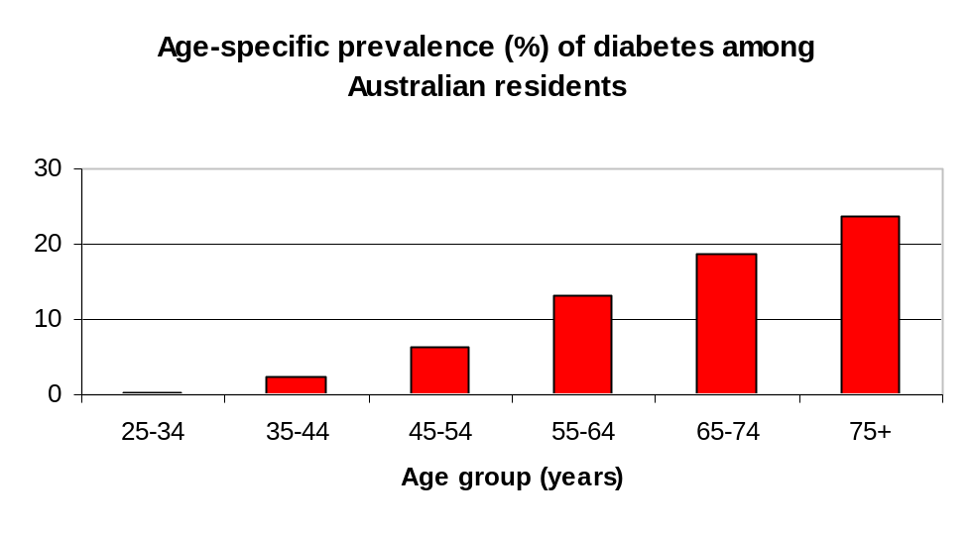
AusDiab found that almost one in 4 Australians aged 25 years and over has either diabetes or a condition of impaired glucose metabolism (a condition associated with substantially increased immediate risk of heart disease as well as increased risk of diabetes).

These AusDiab estimates indicate that there are more than 850,000 Australians aged over 25 years with Type 2 diabetes. They also show that a person aged 75 years old or over is at least 10 times more likely to have diabetes than someone aged 35-44.

4.2. Risk factors

The estimated prevalence of risk factors were also calculated. Risk factors are defined as determinants, characteristics or exposures that are associated with greater risk of ill health. They are strongly influenced by the circumstances in which people live and work.

The 1995 National Health and Nutrition surveys revealed that over 10 million adult Australians (over 80% of the adult population) had at least one of the following risk factors: tobacco smoking, physical inactivity, high blood pressure, or overweight and obesity. (AIHW Heart, Stroke and vascular diseases. 1999) (24)

The project used Australian Institute of Health and Welfare (AIHW- Mathur, 2002)(25) analysis of the 1999-2000 AusDiab; 2001 National Drug Strategy Household Survey and 2000 National Physical Activity Survey (see Figures 2 to 6) to estimate risk factors by age and sex for each Division. The estimates provided by Mathur were based on the following definitions:

  - Insufficient physical activity is less than 150 minutes of physical activity for recreation or exercise (including walking for transport) in the previous week
  - High blood pressure is defined as >= 140/90 mmHg or receiving medication for high blood pressure
  - High blood cholesterol is defined as >= 5.5mmo/L
  - Overweight is defined as Body Mass Index (BMI) >=25. Obestity as BMI >=30.

DDCQIP also provided the mean ten-year risk of coronary heart disease for those aged 25-74 years based on the Framingham equation and as supplied by AusDiab (23). These estimates show an increased risk of coronary heart disease (angina, myocardial infarction, CHD death over ten years) associated with being male and increasing age. Based on these estimates, we could expect over 700,000 Australians currently aged between 25-74 years to suffer a CHD event in the next ten years.

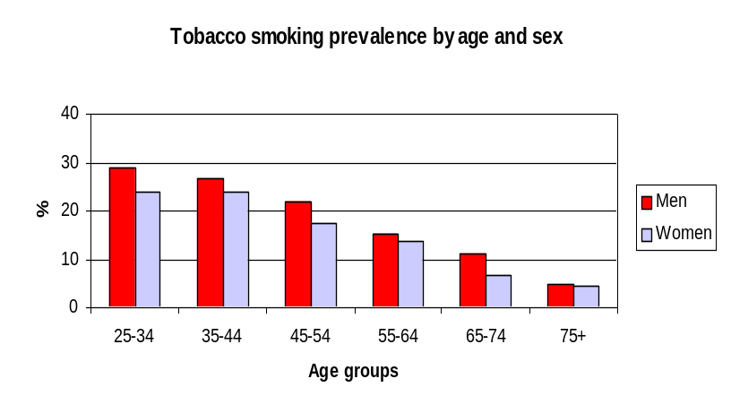Figure 2

Figure 3
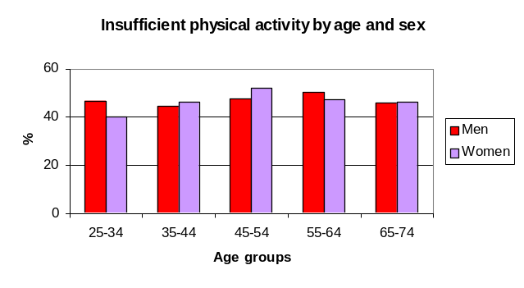

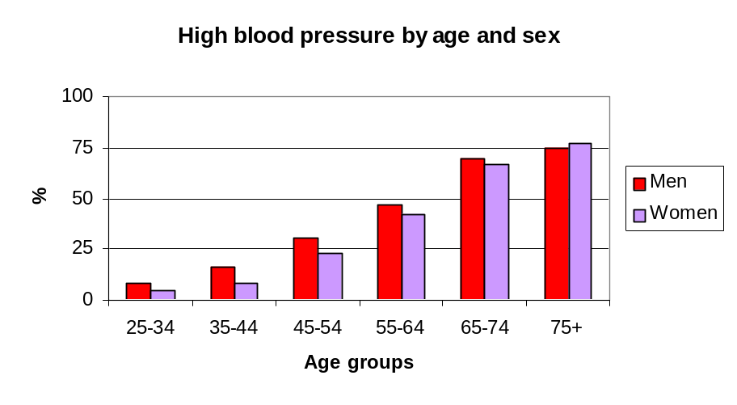Figure 4

Figure 5
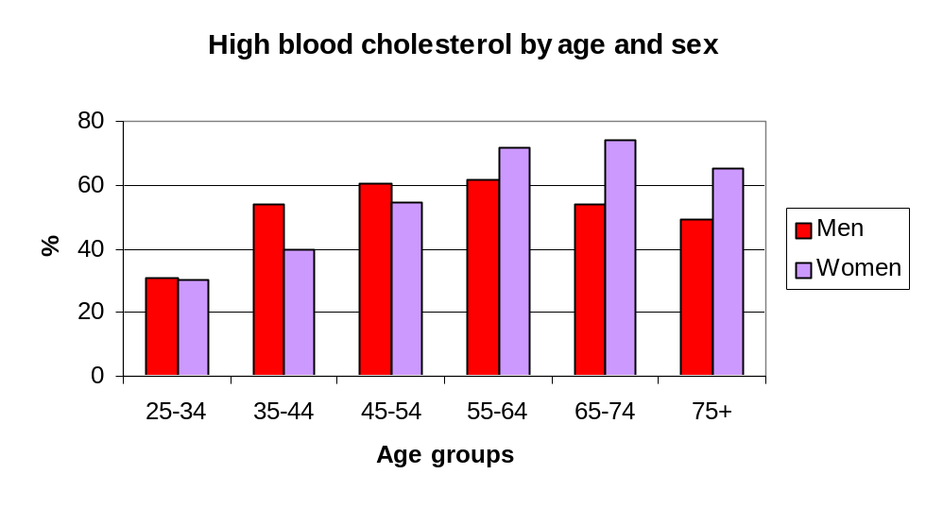

Figure 6
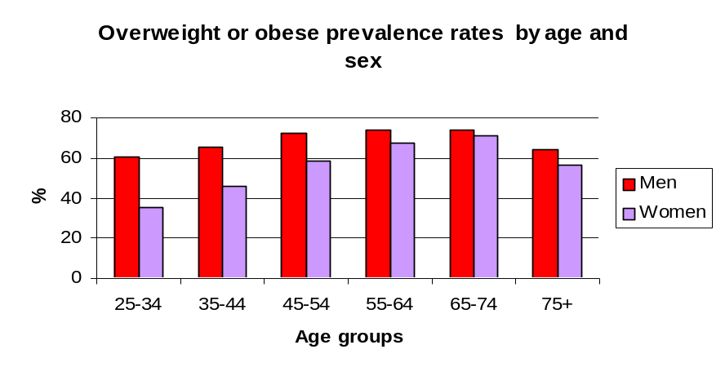
Figure 7

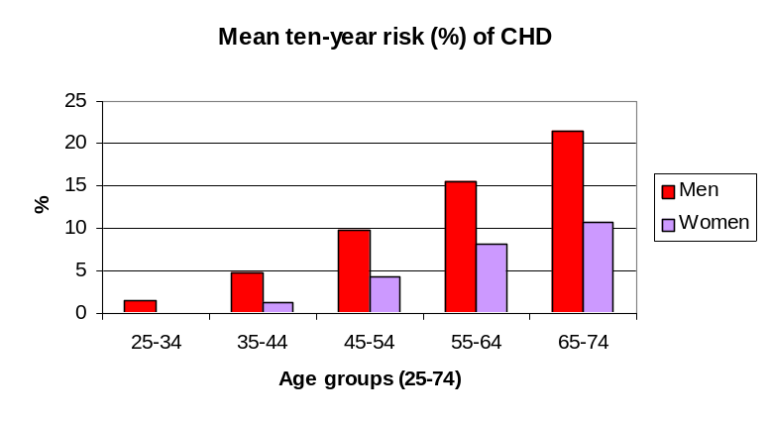

Appendix
SITES WITH A PROGRAM (107)

DIVISIONS OF GENERAL PRACTICE
(121)

DIABETES PROGRAM
(101)

CVD PROGRAM
(70)

NO PROGRAM(14)
DIVISION
PROFILES
NDDCQIP
PART A
DISEASE PROGRAM COLLATION

CARDIAB DIVISIONS
(38)

NON-CARDIAB DIVISIONS
(83)

NDDCQIP
PART B QUALITY OF CARE

PART B
PARTICIPATING SITES (22)

PART B
NON PARTICIPATING SITES (1)

DIABETES & CVD (64)

DIABETES ONLY (37)

CVD & DIABETES (64)

CVD ONLY (6)
> 12 MONTHS DATA (23)
< 12 MONTHS DATA (15)

5. References

